Matt Rumschlag

Java Applications 2

4/18/15

Lab 3.1

Question 1:

onHandleIntent(intent)

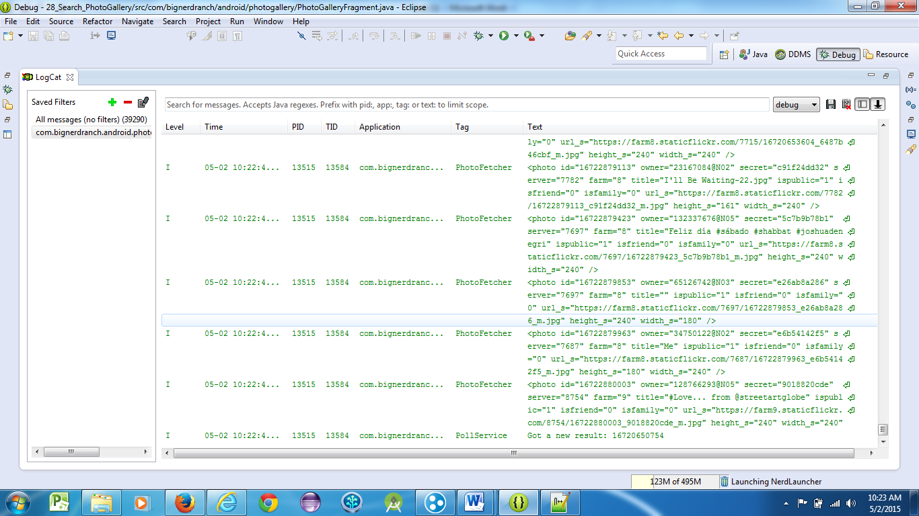

Question 2:

It is only used for older versions of Android.

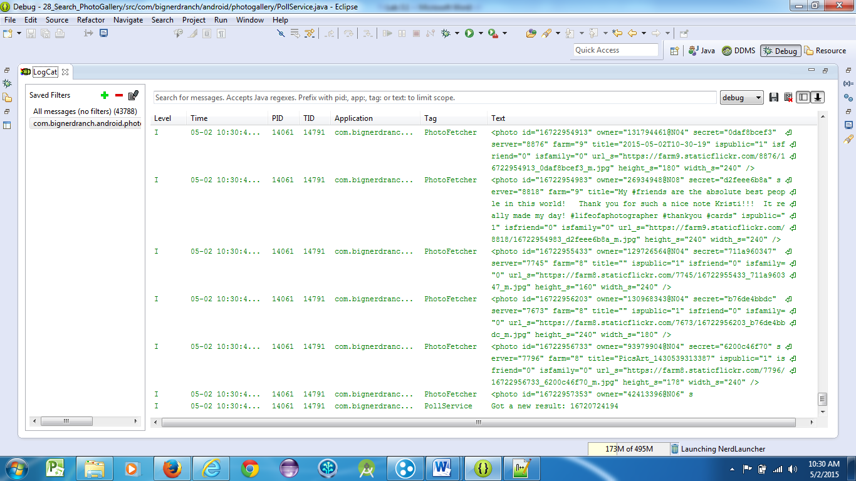

Question 3:

It continues in the background.

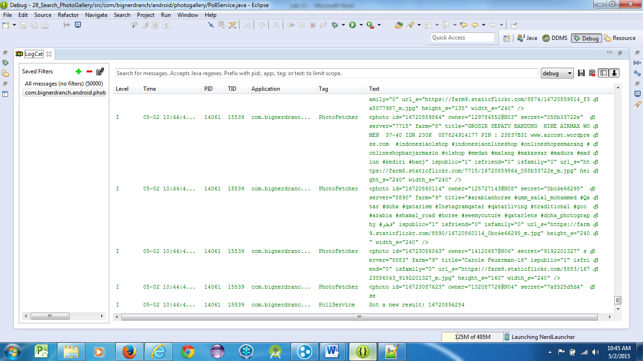  
 

Question 4:

setContentIntent(PendingIntent)

